AOV Z3-HDMI 【65cm】3D Hologram Fan livestream via HDMI
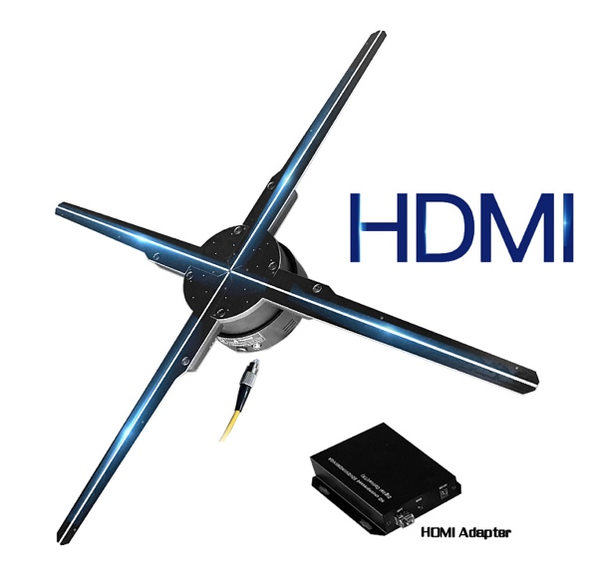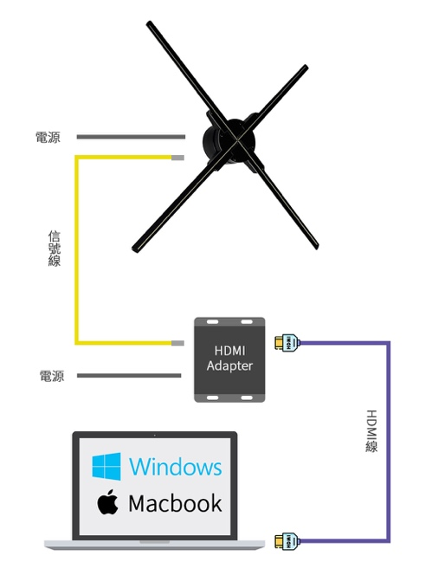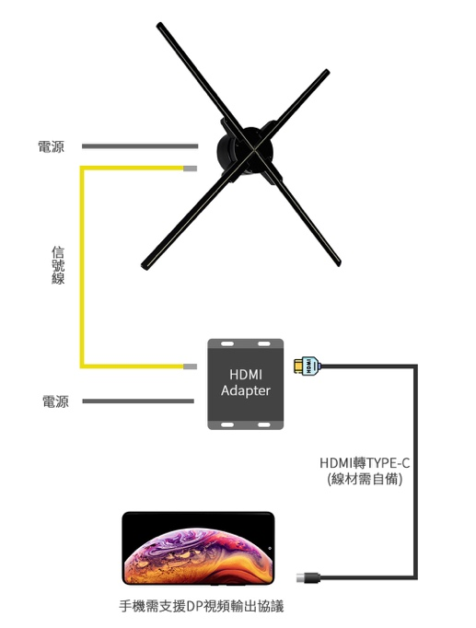
產品名稱：Z3-HDMI
LED數量：960顆
內部儲存：無機身內存，所有影像皆從HDMI傳輸
分辨率：2048×960
亮度： 2000lm
轉速(rpm)：720
額定功率：100W
產品尺寸：65cm*65cm*8cm
包裝尺寸： 76cm*26.6cm*13cm
淨重/毛重: 1.2kg/6.5kg
傳輸方式：HDMI 或 HDMI TO TYPE-C (TYPE-C接口需支援DP顯示輸出協議)
支持格式：JPG、GIF、MP4、RMVB、AVI、MPEG

Product name: Z3-HDMI
Number of LEDs: 960
Internal storage: no on-board memory, all images are transmitted via HDMI
Resolution: 2048×960
Brightness: 2000lm
Speed ​​(rpm): 720
Rated power: 100W
Product size: 65cm*65cm*8cm
Packing size: 76cm*26.6cm*13cm
Net weight/gross weight: 1.2kg/6.5kg
Transmission method: HDMI or HDMI TO TYPE-C (requires support of DP display output protocol)
Supported formats: JPG, GIF, MP4, RMVB, AVI, MPEG

HDMI TO TYPE-C 轉換線需由客人自備

測試是否支援 DP ALT 協議 Android APP https://www.connectdollar.com/apk/tdc

網絡媒體測試TYPE-C支援DP協議產品
